Magnetic Hall Switch  
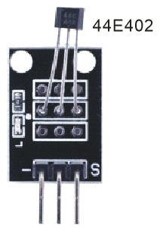

Overview

Hall effect sensors are magnetic sensors, and detect changes in the magnetic field. Where analog Hall sensors vary their voltage output linearly in relation to the strength or weakness of the field, a magnetic switch sensor such as 44E402 simply signals the presence or absence of a nearby magnet, which makes them ideal for use with a simple bar or rod magnet. In this experiment, you’ll use a magnetic hall switch and LED to illuminate a light whenever your sensor detects a nearby magnet.

Materials Needed

Raspberry Pi x1

Breadboard x1

Magnetic Hall sensor x1

LED (3 pin) x1

Resistor(330Ω) x1

Dupont jumper wires

Any magnet (you provide)

Experimental Procedure

1. If you have not done so already, prepare your development system by installing the Python interpreter, RPi.GIO library, and wiringPi library as described in READ_ME.TXT.
2. Install the Hall magnetic switch sensor, three-pin LED and resistor on your breadboard, and use Dupont jumper wires to connect them to each other and your Raspberry Pi as illustrated in the Wiring Diagram below. Note you will connect only two of the three pins on the LED.
3. Execute the sample stored in this experiment’s subfolder.

If using C, compile and execute the C code:  
cd Code/C  
gcc magneticHall.c -o magneticHall.out –lwiringPi  
./ magneticHall.out

If using Python, launch the Python script:  
cd Code/Python  
python magneticHall.py

1. Make experimental observations.  
   The code simply pushes the state of the switch on to the state of the LED, so when you hold a magnet close to the sensor, the Hall effect closes the switch and the LED illuminates.

Wiring Diagram

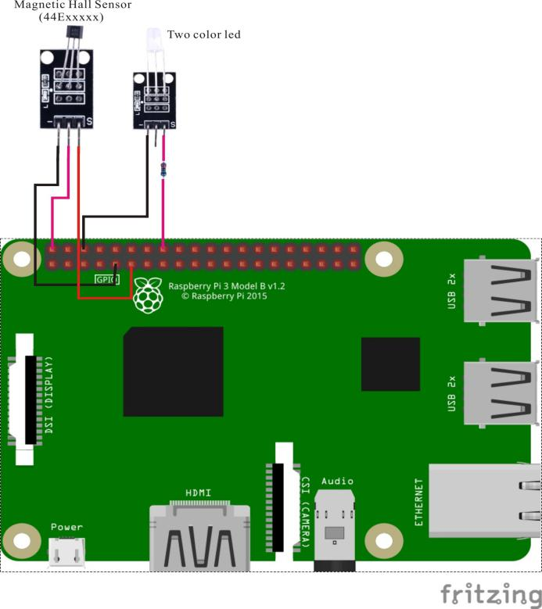

Magnetic Hall Sensor pin position:

"S" ↔ Raspberry Pi pin 11

"+" ↔ Raspberry Pi +5V

"-" ↔ Raspberry Pi GND

LED pin position:

"S" ↔ Raspberry Pi pin 16(through resistor)

"-" ↔ Raspberry Pi pin GND

Sample code

Python Code

#!/usr/bin/env python

import time

import RPi.GPIO as GPIO

LedPin = 16

SensorPin = 11

def init():

GPIO.setmode(GPIO.BOARD)

GPIO.setup(LedPin, GPIO.OUT)

GPIO.setup(SensorPin, GPIO.IN)

def loop():

while True:

if(GPIO.input(SensorPin)):

GPIO.output(LedPin, GPIO.LOW)

else:

GPIO.output(LedPin, GPIO.HIGH)

time.sleep(0.2)

if __name__ == '__main__':

init()

try:

loop()

except KeyboardInterrupt:

print 'The end !'

C Code

#include <wiringPi.h>

#include <stdio.h>

#include <string.h>

#include <errno.h>

#include <stdlib.h>

#define LedPin 4

#define SensorPin 0

int main(void)

{

if(wiringPiSetup() == -1)

{

printf("setup wiringPi failed !");

return 1;

}

pinMode(LedPin, OUTPUT);

pinMode(SensorPin, INPUT);

while(1)

{

if(digitalRead(SensorPin))

{

digitalWrite(LedPin, LOW);

}

else

{

digitalWrite(LedPin, HIGH);

}

delay(200);

}

return 0;

}